WT Assignment 2
Neeti Kurulkar
Restaurant Website

Website:

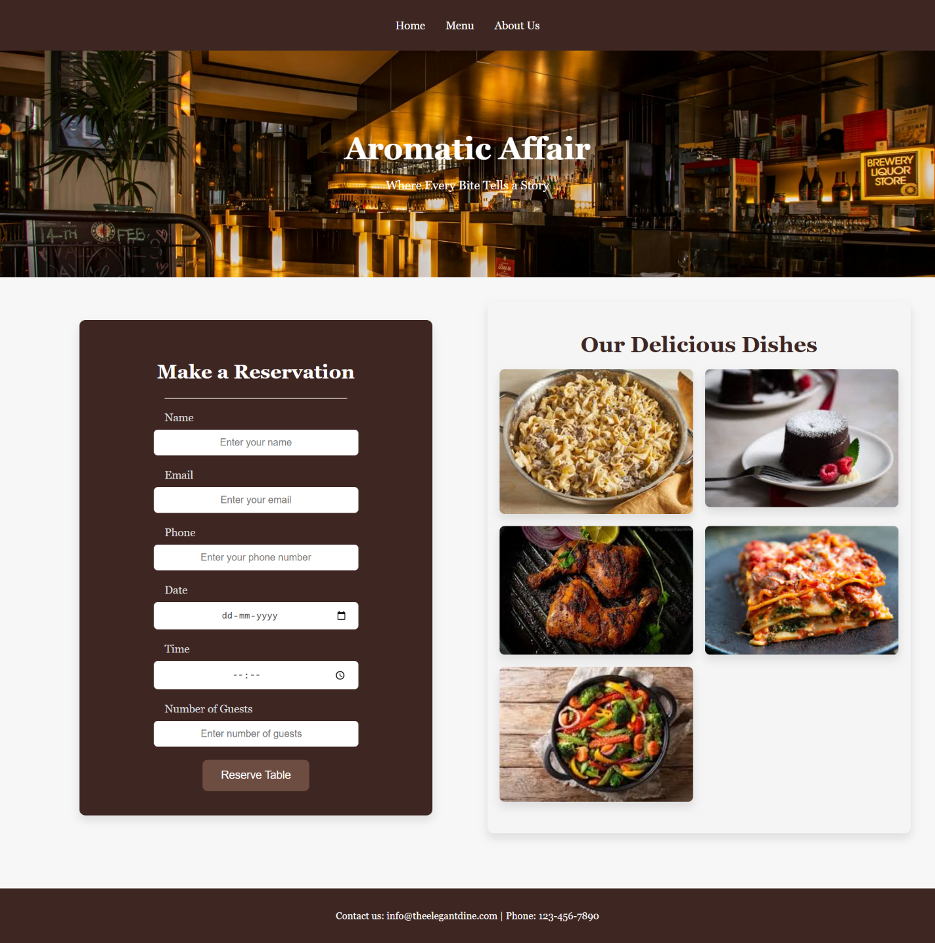

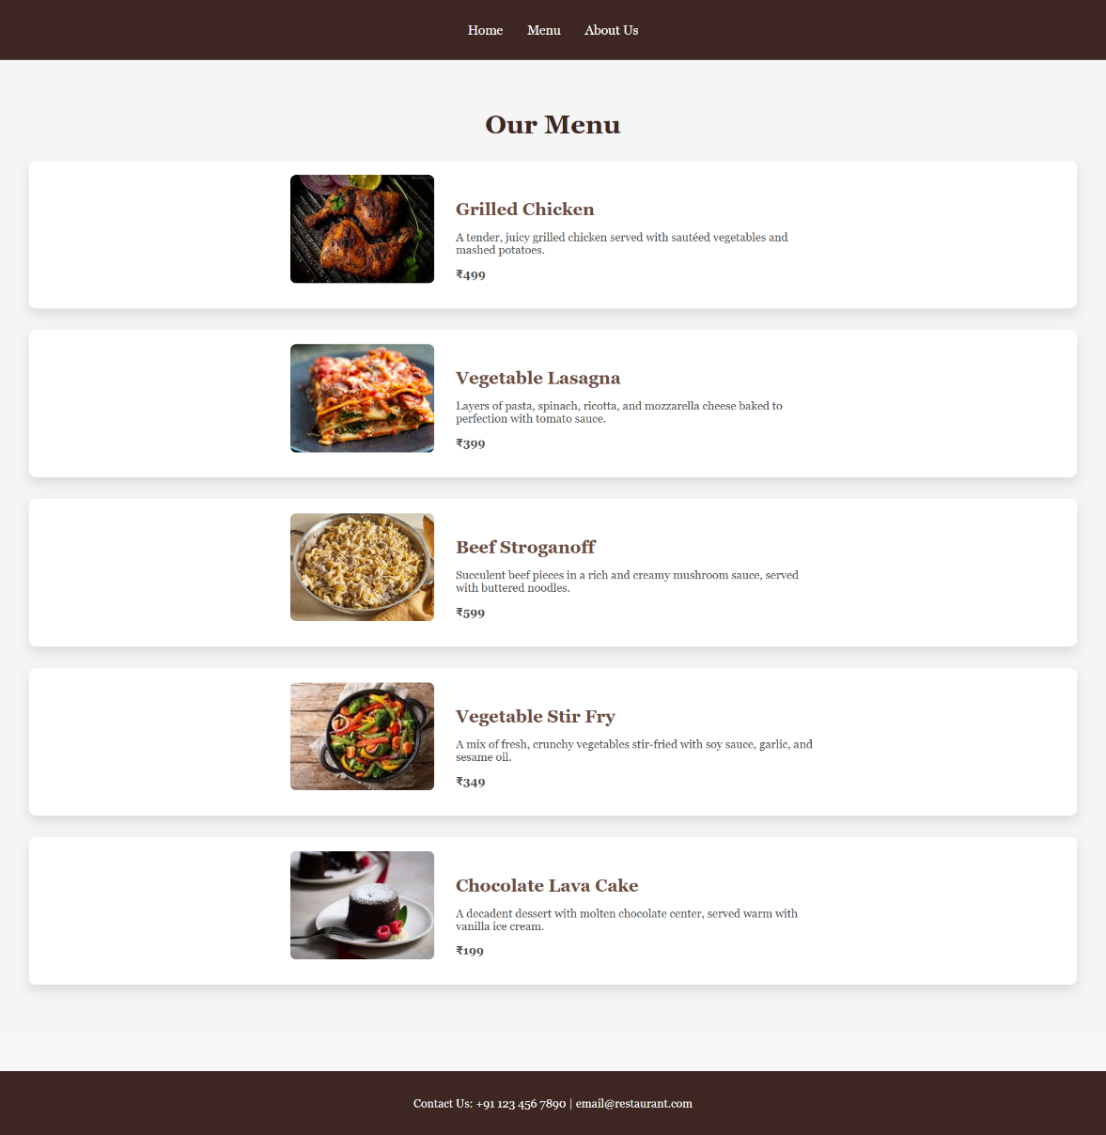

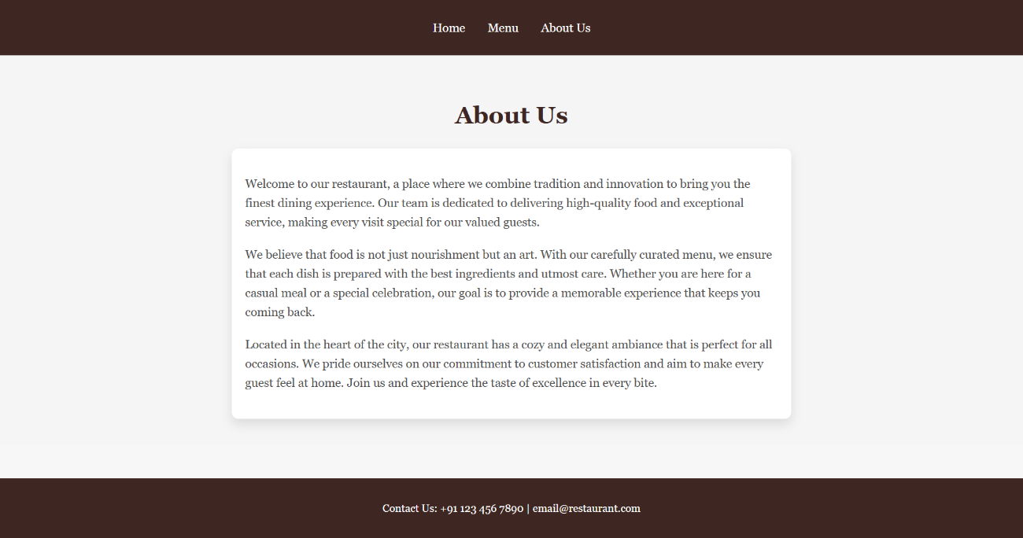
Code:
- index.html

<!DOCTYPE html>
<html lang="en">
<head>
<meta charset="UTF-8" />
<meta name="viewport" content="width=device-width, initial-scale=1.0" />
<title>Restaurant</title>
<link rel="stylesheet" href="styles.css" />
</head>
<body>
<!-- Navbar -->
<nav class="navbar">
<ul>
<li><a href="index.html">Home</a></li>
<li><a href="menu.html">Menu</a></li>
<li><a href="about.html">About Us</a></li>
</ul>
</nav>

<!-- Header -->
<header class="header">
<h1>Aromatic Affair</h1>
<p>Where Every Bite Tells a Story</p>
</header>

<div class="main-content">
<!-- Reservation Form -->
<section class="reservation" id="reservation">
<h2>Make a Reservation</h2>
<div class="separator"></div>
<form action="#" method="POST">
<label for="name">Name</label>
<input
type="text"
id="name"
name="name"
placeholder="Enter your name"
required
/>

<label for="email">Email</label>
<input
type="email"
id="email"
name="email"
placeholder="Enter your email"
required
/>

<label for="phone">Phone</label>
<input
type="tel"
id="phone"
name="phone"
placeholder="Enter your phone number"
required
/>

<label for="date">Date</label>
<input type="date" id="date" name="date" required />

<label for="time">Time</label>
<input type="time" id="time" name="time" required />

<label for="guests">Number of Guests</label>
<input
type="number"
id="guests"
name="guests"
placeholder="Enter number of guests"
required
min="1"
max="20"
/>

<button type="submit">Reserve Table</button>
</form>
</section>

<!-- Gallery Section -->
<div class="gallery">
<h2>Our Delicious Dishes</h2>
<div class="gallery-images">
<img src="images/beef-stroganoff.jpeg" alt="Dish 1">
<img src="images/choco-lava-cake.jpeg" alt="Dish 2">
<img src="images/grilled-chicken.jpeg" alt="Dish 3">
<img src="images/vegetable-lasagna.jpeg" alt="Dish 4">
<img src="images/vegetable-stir-fry.jpeg" alt="Dish 5">
</div>
</div>
</div>

<!-- Footer -->
<footer>
<p>Contact us: info@theelegantdine.com | Phone: 123-456-7890</p>
</footer>
</body>
</html>

- menu.html

<!DOCTYPE html>
<html lang="en">
<head>
<meta charset="UTF-8" />
<meta name="viewport" content="width=device-width, initial-scale=1.0" />
<title>Menu - Our Restaurant</title>
<link rel="stylesheet" href="styles.css" />
</head>
<body>
<!-- Navbar -->
<nav class="navbar">
<ul>
<li><a href="index.html">Home</a></li>
<li><a href="menu.html">Menu</a></li>
<li><a href="about.html">About Us</a></li>
</ul>
</nav>

<div class="menu-container">
<h2>Our Menu</h2>
<div class="menu-item">
<img src="images/grilled-chicken.jpeg" alt="grilled-chicken" />
<div class="dish-details">
<h3>Grilled Chicken</h3>
<p>
A tender, juicy grilled chicken served with sautéed vegetables and
mashed potatoes.
</p>
<p class="price">₹499</p>
</div>
</div>

<div class="menu-item">
<img src="images/vegetable-lasagna.jpeg" alt="vegetable-lasagna" />
<div class="dish-details">
<h3>Vegetable Lasagna</h3>
<p>
Layers of pasta, spinach, ricotta, and mozzarella cheese baked to
perfection with tomato sauce.
</p>
<p class="price">₹399</p>
</div>
</div>

<div class="menu-item">
<img src="images/beef-stroganoff.jpeg" alt="beef-stroganoff" />
<div class="dish-details">
<h3>Beef Stroganoff</h3>
<p>
Succulent beef pieces in a rich and creamy mushroom sauce, served
with buttered noodles.
</p>
<p class="price">₹599</p>
</div>
</div>

<div class="menu-item">
<img src="images/vegetable-stir-fry.jpeg" alt="vegetable-stir-fry" />
<div class="dish-details">
<h3>Vegetable Stir Fry</h3>
<p>
A mix of fresh, crunchy vegetables stir-fried with soy sauce,
garlic, and sesame oil.
</p>
<p class="price">₹349</p>
</div>
</div>

<div class="menu-item">
<img src="images/choco-lava-cake.jpeg" alt="choco-lava-cake" />
<div class="dish-details">
<h3>Chocolate Lava Cake</h3>
<p>
A decadent dessert with molten chocolate center, served warm with
vanilla ice cream.
</p>
<p class="price">₹199</p>
</div>
</div>
</div>

<footer>
<p>Contact Us: +91 123 456 7890 | email@restaurant.com</p>
</footer>
</body>
</html>

- about.html

<!DOCTYPE html>
<html lang="en">
<head>
<meta charset="UTF-8" />
<meta name="viewport" content="width=device-width, initial-scale=1.0" />
<title>About Us - Our Restaurant</title>
<link rel="stylesheet" href="styles.css" />
</head>
<body>
<!-- Navbar -->
<nav class="navbar">
<ul>
<li><a href="index.html">Home</a></li>
<li><a href="menu.html">Menu</a></li>
<li><a href="about.html">About Us</a></li>
</ul>
</nav>

<div class="about-container">
<h2>About Us</h2>
<div class="about-content">
<p>
Welcome to our restaurant, a place where we combine tradition and
innovation to bring you the finest dining experience. Our team is
dedicated to delivering high-quality food and exceptional service,
making every visit special for our valued guests.
</p>

<p>
We believe that food is not just nourishment but an art. With our
carefully curated menu, we ensure that each dish is prepared with the
best ingredients and utmost care. Whether you are here for a casual
meal or a special celebration, our goal is to provide a memorable
experience that keeps you coming back.
</p>

<p>
Located in the heart of the city, our restaurant has a cozy and
elegant ambiance that is perfect for all occasions. We pride ourselves
on our commitment to customer satisfaction and aim to make every guest
feel at home. Join us and experience the taste of excellence in every
bite.
</p>
</div>
</div>

<footer>
<p>Contact Us: +91 123 456 7890 | email@restaurant.com</p>
</footer>
</body>
</html>

- styles.css

/* General Styles */
body {
font-family: "Georgia", serif;
margin: 0;
padding: 0;
background-color: #f7f7f7;/* Light background */
color: #4f4f4f;
}

/* Navbar Styling */
.navbar {
background-color: #3e2723;
padding: 15px 0;
text-align: center;
}

.navbar ul {
list-style: none;
padding: 0;
}

.navbar ul li {
display: inline;
margin: 0 15px;
}

.navbar ul li a {
text-decoration: none;
color: white;
font-size: 18px;
}

.navbar ul li a:hover {
color: #b5a6a1;
}

/* Header Styling */
.header {
position: relative;
background: url("images/restaurant-image.jpg") no-repeat center center/cover;
color: white;
text-align: center;
padding: 100px 20px;
background-size: cover;
}

.header h1 {
font-size: 50px;
margin-bottom: 10px;
}

.header p {
font-size: 20px;
margin-bottom: 40px;
}

/* Main Content Section */
.main-content {
display: flex;
justify-content: space-between;
padding: 40px;
}

/* Reservation Form Styling */
.reservation {
width: 45%;
text-align: center;
padding: 40px;
background-color: #3e2723;
margin: 30px auto;
border-radius: 10px;
max-width: 500px;
box-shadow: 0 8px 15px rgba(0, 0, 0, 0.1);
}

.reservation h2 {
font-size: 32px;
margin-bottom: 25px;
color: white;
}

.reservation .separator {
border-top: 2px solid #b5a6a1;
width: 60%;
margin: 20px auto;
}

.reservation label {
font-size: 18px;
color: #ddd;
font-weight: 500;
text-align: left;
display: block;
margin-bottom: 8px;
width: 60%;
margin-left: auto;
margin-right: auto;
}

.reservation input,
.reservation select {
width: 60%;
padding: 12px 18px;
font-size: 16px;
border: 2px solid #3e2723;
border-radius: 8px;
background-color: white;
color: #4f4f4f;
margin-bottom: 20px;
text-align: center;
display: block;
margin-left: auto;
margin-right: auto;
transition: border-color 0.3s ease;
}

.reservation input:focus,
.reservation select:focus {
border-color: #b5a6a1;
outline: none;
}

.reservation button {
padding: 15px 30px;
background-color: #6d4c41;
color: white;
font-size: 18px;
border-radius: 8px;
border: none;
cursor: pointer;
transition: background-color 0.3s ease;
}

.reservation button:hover {
background-color: #5d4037;
}

.reservation button:active {
transform: translateY(0);
}

/* Gallery Section */
.gallery {
width: 45%;
padding: 20px;
background-color: #f5f5f5;
border-radius: 10px;
box-shadow: 0 8px 15px rgba(0, 0, 0, 0.1);
}

.gallery h2 {
font-size: 36px;
color: #3e2723;
margin-bottom: 20px;
text-align: center;
}

.gallery-images {
display: grid;
grid-template-columns: repeat(auto-fill, minmax(250px, 1fr));
gap: 20px;
justify-items: center;
}

.gallery-images img {
width: 100%;
height: auto;
border-radius: 8px;
box-shadow: 0 8px 15px rgba(0, 0, 0, 0.1);
transition: transform 0.3s ease;
}

.gallery-images img:hover {
transform: scale(1.05);
}

/* Menu Page Styles */
.menu-container {
text-align: center;
padding: 40px;
background-color: #f5f5f5;
}

.menu-container h2 {
font-size: 36px;
margin-bottom: 30px;
color: #3e2723;
}

/* Flexbox adjustments for responsiveness */
.menu-item {
display: flex;
justify-content: center;
align-items: center;
margin-bottom: 30px;
background-color: #ffffff;
border-radius: 10px;
box-shadow: 0 8px 15px rgba(0, 0, 0, 0.1);
padding: 20px;
flex-wrap: wrap;
}

.menu-item img {
width: 200px;
height: 150px;
object-fit: cover;
border-radius: 8px;
margin-right: 30px;
margin-bottom: 15px;
}

.dish-details {
max-width: 500px;
text-align: left;
flex-grow: 1;
}

.dish-details h3 {
font-size: 24px;
color: #6d4c41;
margin-bottom: 10px;
}

.dish-details p {
font-size: 16px;
color: #4f4f4f;
margin-bottom: 10px;
}

.price {
font-size: 18px;
font-weight: bold;
color: #3e2723;
}

/* Media Queries for Responsiveness */
@media (max-width: 768px) {
.menu-item {
flex-direction: column;
align-items: center;
}

.menu-item img {
margin-right: 0;
margin-bottom: 20px;
width: 100%;
height: auto;
}

.dish-details {
text-align: center;
max-width: 90%;
}

.menu-container h2 {
font-size: 28px;
}
}

@media (max-width: 480px) {
.menu-container h2 {
font-size: 24px;
}

.price {
font-size: 16px;
}

.dish-details p {
font-size: 14px;
}
}

/* Footer Styles */
footer {
text-align: center;
padding: 20px;
background-color: #3e2723;
color: white;
margin-top: 50px;
}

/* About Us Page Styles */
.about-container {
text-align: center;
padding: 40px;
background-color: #f5f5f5;
}

.about-container h2 {
font-size: 36px;
margin-bottom: 30px;
color: #3e2723;
}

.about-content {
max-width: 800px;
margin: 0 auto;
padding: 20px;
background-color: #ffffff;
border-radius: 10px;
box-shadow: 0 8px 15px rgba(0, 0, 0, 0.1);
text-align: left;
}

.about-content p {
font-size: 18px;
color: #4f4f4f;
line-height: 1.6;
margin-bottom: 20px;
}

